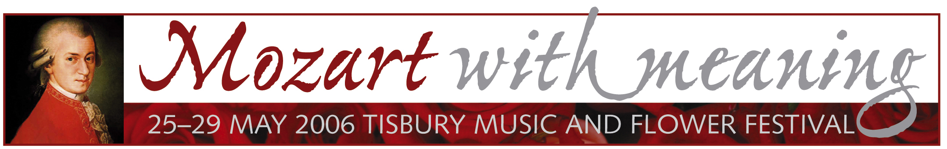

NEWS RELEASE 21 JANUARY 2006

TISBURY TO HOST SPECTACULAR MOZART CONCERT
AND FLOWER FESTIVAL 25-29 MAY

The picturesque St John the Baptist Church in Tisbury, near Salisbury, will host a spectacular charity concert, gala dinner and flower festival on 25-29 May 2006 to celebrate the 250th birthday of the great classical composer Wolfgang Amadeus Mozart.

The Mozart with Meaning Tisbury Music and Flower Festival runs over the spring bank holiday weekend and opens with an Ascension Day mass led by the Bishop of Salisbury, Rt Rev Dr David Stancliffe, with St John’s choir singing Mozart’s Coronation Mass. Proceeds and donations from the five-day musical and floral extravaganza will go to Southampton Hospital Children’s Haemo Dialysis Unit and the restoration of St John the Baptist Church in Tisbury, a Norman cruciform church with Saxon origins.

The festival centrepiece is a gala dinner and concert of Mozart’s music on Friday, 26 May performed by the internationally acclaimed conductor Paul Brough and the All Saints, Margaret Street Church Choir based in London’s West End, where he is director of music. Among the selections Paul Brough has chosen for this special Mozart programme is Laudate Dominum, a serene feature of the Solemn Vespers with a beautiful long-spun cantabile line for solo soprano, and Mozart’s complex Fantasia in F Minor which he wrote for what was the iPod of his day, a mechanical, self-playing organ.

“Tisbury’s fine Father Willis organ will be heard to great effect in the Fantasia. The musical programme will also feature operatic arias sung by members of the All Saints, Margaret Street Choir who include leading soloists from the Sixteen and Monteverdi choirs as well as the Glyndebourne Chorus,” explains conductor Paul Brough who is also the director of leading period instrument orchestra The Hanover Band.

Major festival highlights include the Symphony of Flowers festival – a display of 35 floral arrangements based on the theme of Mozart’s life and music – and a concert by one of London’s top rock/soul party bands, Shoot the Moon. Other activities include concerts by local musicians, ballroom dancing, riverside picnics and cream teas.

“Tisbury's Mozart with Meaning Festival promises to be a feast for all the senses: inspiring, beautiful and full of joy. Tisbury people love their village, their community and their church and are looking forward eagerly to sharing them with many visitors from far and wide and all walks of life over the Ascensiontide weekend," says Rev Humphrey Southern, Rector of St John the Baptist Parish Church in Tisbury.

Tickets for the Mozart with Meaning Festival Concert conducted by Paul Brough and table bookings for the Gala Dinner on Friday, 26 May are limited and should be purchased in advance from the festival coordinator Clive Fairclough 07962 023882 or email info@tisburymozartfestival.com

For more information visit: www.tisburymozartfestival.com

– ends –
Photos: 1) St John the Baptist Parish Church, Tisbury, Wiltshire; 2) Mozart with Meaning Tisbury Music and Flower Festival brochure cover

Media contact: Liz Coyle-Camp or Christine Nielsen-Craig, E=MC2 Public Relations, 01747 871752
Email: christine@emc2publicrelations.com

